Menu
Starters:
- On the house  (bread basket with herb butter) | -
- Soup of the day | 4.50€
- Bread basket with herb butter | 3.00€
- Seasoned olives | 3.00€
- Onion rings in tempura | 7.50€
- Potatoes à Manezinho  (French fries with bacon and cheese sauce) | 8.00€
- São Jorge cheese platter  (4, 7, 12 and 24 months matured cheese with honey) | 17.00€
- Cheese platter  (Regional cheese with compote and toast) | 13.00€
- Mixed platter  (Regional cheese, smoked ham, chorizo, bread, compote and seasoned olives) | 15.00€
- Shrimps in garlic  (Seasoned shrimps, served with a basket of bread) | 14.00€
- Manezinho shrimps  (Fried shrimps in tempura and sauces: turmeric, tartar and ketchup) | 17.00€
- Fried chorizo with honey and rosemary  (Served with a basket of bread) | 7.00€
- Fried morcela (blackpudding) with orange and pineapple | 10.00€
- Crispy chicken sticks  (With hot sauce) | 9.00€


Salads:
- Simple salad  (mixture of salad, red onion and cherry tomatoes) | 8.00€
- Shrimp salad  (fried shrimp, mixture of salad, red onion, cherry tomatoes and vinaigrette) | 19.00€
- Grilled chicken salad  (grilled chicken, mixture of salad, red onion, cherry tomatoes and vinaigrette) | 16.00€
- Vegan salad  (tofu, mixture of salad, red onion, cherry tomatoes, mixture of sautéed rice and vegetables of the season) | 18.00€
- Vegetarian salad  (mixture of salad, red onion, cherry tomatoes, mixture of sautéed rice and vegetables of the season and roasted potato) | 16.00€

Hamburger:
- Manezinho Hamburger  (Hamburger bun, Thousand Island sauce, two layers of ground beef, onion marmalade, two slices of bacon, two slices of cheddar, onion rings and french fries) | *19.00€
- Manezinho spicy hamburger  (Hamburger bun, Thousand Island sauce, spicy sauce, two layers of ground beef, onion marmalade, two slices of bacon, two slices of cheddar, jalapenos, onion rings and french fries) | *20.00€
- Manezinho simple hamburger  (Hamburger bun, Thousand Island sauce, ground beef, onion marmalade, bacon, cheddar, onion rings and french fries) | *15.00€
- Manezinho spicy simple hamburger  (Hamburger bun, Thousand Island sauce, spicy sauce, ground beef, onion marmalade, bacon, cheddar, jalapenos, onion rings and french fries) | *16.00€
- Tuna hamburger  (Hamburger bun, tartar sauce, tuna steak, onion marmalade, onion rings and french fries) | *18.00€
- Spicy tuna hamburger  (Hamburger bun, tartar sauce, spicy sauce, tuna steak, onion marmalade, jalapenos, onion rings and french fries) | *19.00€

* Sauces not included

Meat:
- Manezinho steak (280 gr.)  (Filet Mignon on a bed of spinach, baked sweet potatoes and mustard sauce) | 30.50€
- Grilled chicken breast  (with herb butter and baked potatoes with São Jorge cheese) | *18.50€
- Vazia (Sirloin) (280 gr.)  (with herb butter and baked potatoes with São Jorge cheese) | *22.50€
- Secrets of black Iberian pig (280 gr.)  (a delicate piece of meat that “hides” inside the layers of bacon and baked potatoes with São Jorge cheese) | *23.50€
- Picanha (Sirloin cap) (280 gr.) imported  (with herb butter and baked potatoes with São Jorge cheese) | *25.50€
- Selection of meats (2 persons)  (picanha (sirloin cap), vazia (sirloin), secrets of the black Iberian pig and baked potatoes with São Jorge cheese) | *67.50€

* Sauces not included.

Fish:
- Manezinho octopus (300 gr)  (with baked potatoes) | 29.00€
- White fish tempura (300 gr.)  (on a bed of mixed salad and tartar sauce) | *20.00€
- Seasonal grilled fish*  (whole 800 gr./1 kg, sliced 280/ 300 gr., with tomato risotto and sauce) | (Price on request)  *20€ to 45€
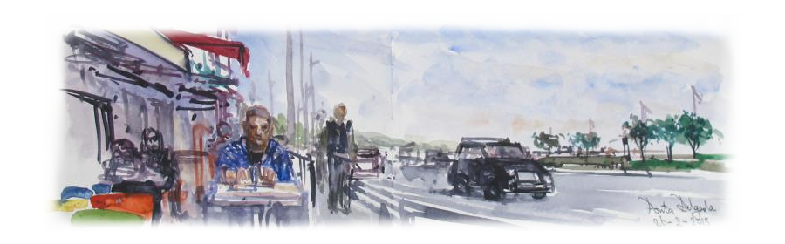


Side dishes:
- White rice | 2.50€
- Backed potato | 2.50€
- Sweet backed potato | 2.50€
- Tomato risotto | 3.00€
- Potato salad | 2.50€
- French fries | 3.50€
- Sautéed spinach | 3.50€
- Sautéed vegetables | 4.00€
Extra:
- Onion marmalade | 1.50€
- Manezinho toast | 2.00€
- Fried egg | 1.50€
Sauces:
- Ketchup | 1.50€
- Garlic and turmeric sauce | 1.50€
- Tartar sauce | 1.50€
- Mustard sauce | 2.00€
- Spicy sauce | 2.00€
- S. Jorge cheese sauce | 2.00€
- Selection of sauces  (garlic and turmeric, ketchup and tartar sauce) | 3.50€

Desserts:
- Chocolate mousse | 4.00€
- Coconut and passion fruit mousse | 4.00€
- Pannacotta | 4.00€
- Seasonal fruit salad | 5.00€


